Dataset - DRT121C - Car driving tests conducted, passed and pass rates by month, financial quarter and financial year, gender, Great Britain, from April 2007 to September 2025

This document walks through five steps used to create a clean version of the DRT121C that you can use as data for your data journalism portfolio. The aim was to create a file that could be analysed and visualised with a minimum of issues. But, you should familiarise yourself with the process. Each data set will require some cleaning and adjustment. The key is to be purposeful with each step.

In the case of this data, there were five steps.

Step 1: Remove the headers 2
2
Step 2: Keep the useful core data 2
3
Step 3: Identify dirty data. 3
4
Step 4:Adding a cleaner year 5
5
Step 5: Saving a cleaned-up version 6
6

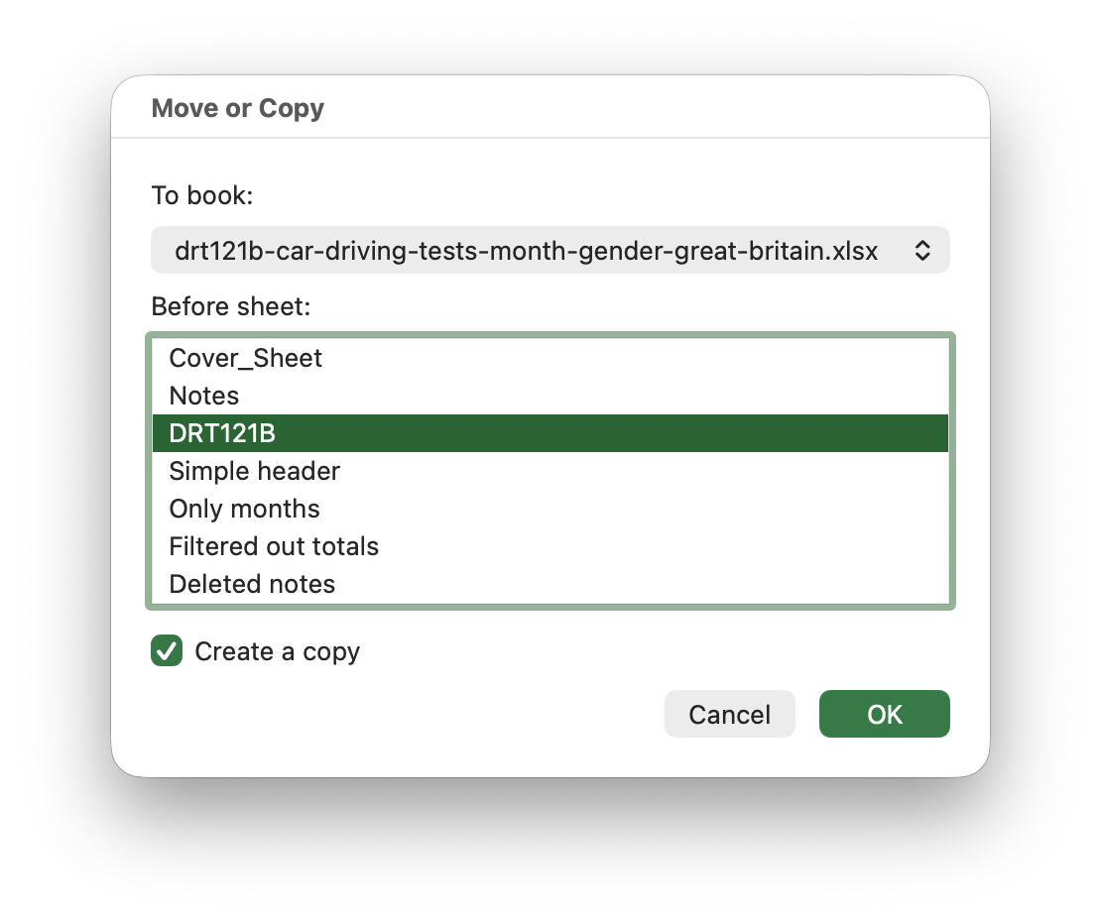
Step 1: Remove the headers

- Right-click the tab DRT121B
- Select Move or Copy
- Highlight DRT121B
- Check Create a copy
- Rename the duplicate sheet - Simple Header
- Select the simple header sheet
- Highlight rows 1-5
- Select Edit > Delete to remove the rows and content.

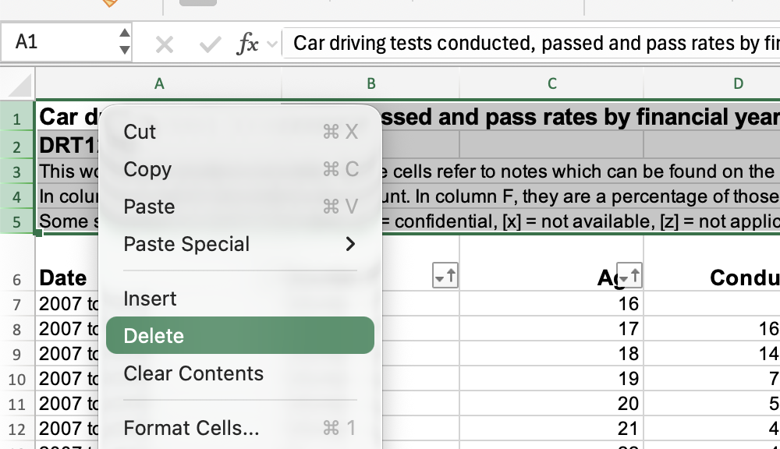

Why?
Removing headers makes it easier to apply filters, start pivot tables etc. Creating a new, duplicate sheet may seem like overkill, but it pays to keep a copy of your raw data - just in case.

Step 2: Keep the useful core data
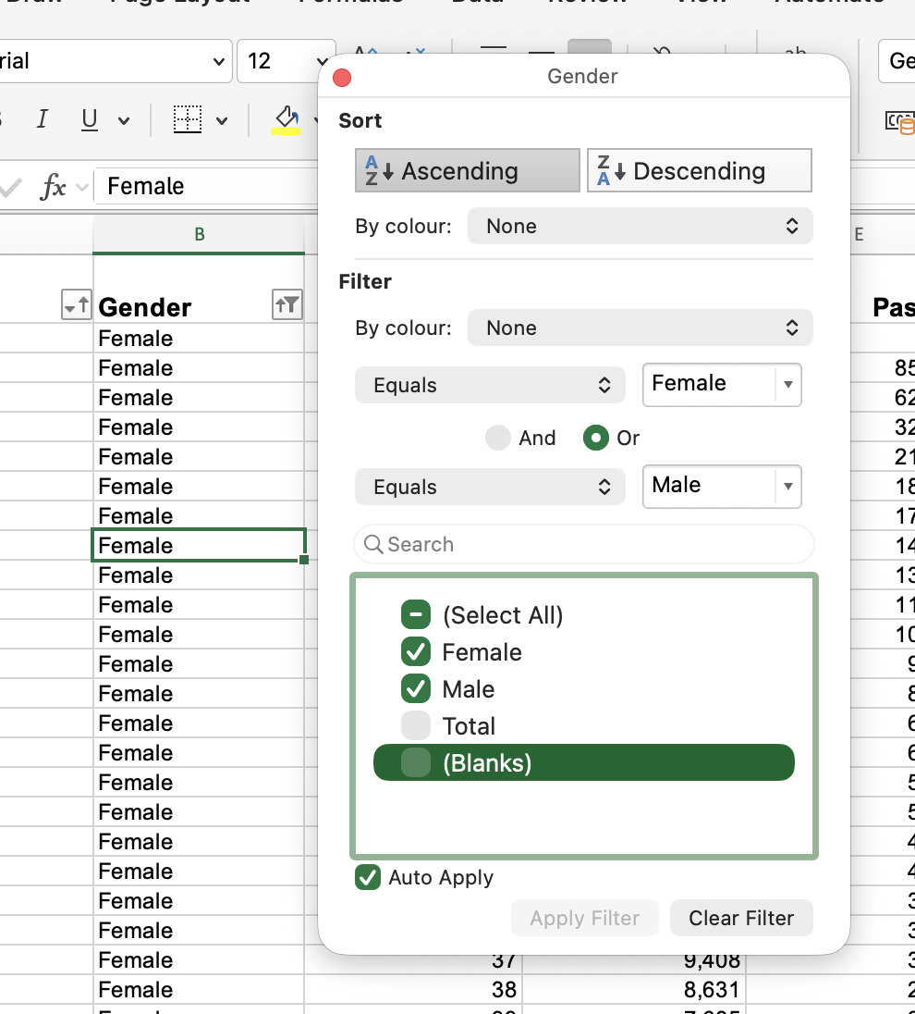

- Select the filter on the Gender column
- Uncheck Total and (Blanks)
- Select the filter on the Age column
- Uncheck Total
- In the new sheet, select Edit >Find > Go To… > Special… > Visible cells only
- Click OK to apply selection
- Click + on the sheet tabs to add a new blank sheet to the workbook
- Rename the sheet - No Totals
- Use Edit > Paste to add the selected cells

Why?
The data set contains a number of summary rows- Totals. These might confuse any formulas we apply. So we can remove them and rely on the raw data and our own calculations. There is a caveat here. The spreadsheet notes say “Total tests may be higher than the sum of male and female tests, as the candidate's gender is not always recorded.” We should be clear about that when communicating results. For example, we might say “Where the gender was recorded…”

Step 3: Identify dirty data.
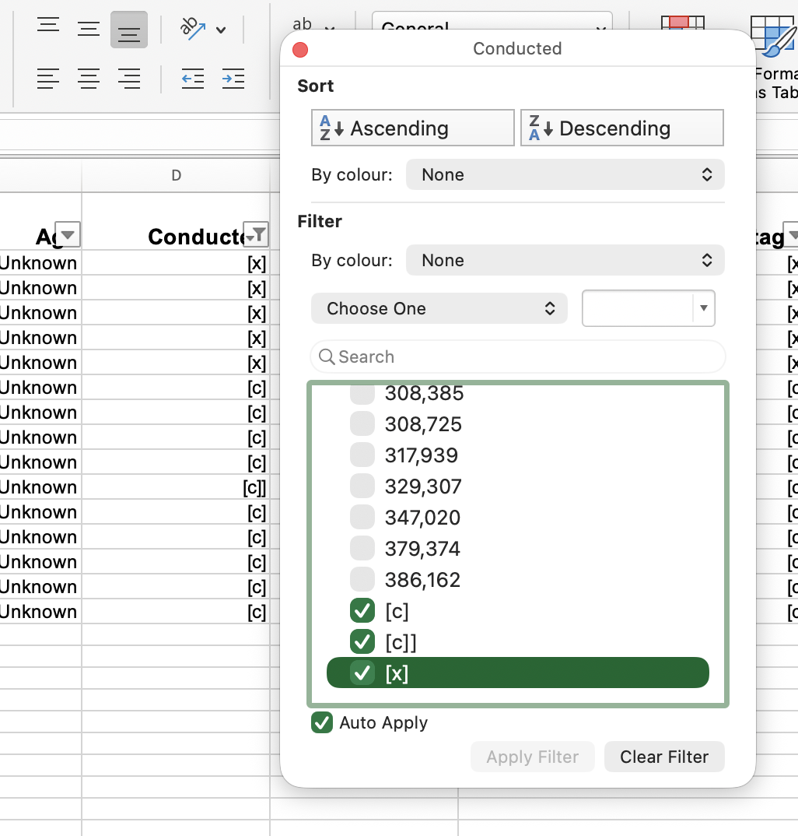
- In the No Totals sheet click any cell
- Press CTRL+ SHIFT + L to toggle the column filters on.
- In the Conducted column use the filter to only show the text entries
- Go to Row 1358 and change the [c]] to [c]

Why?
Dirty data refers to a number of things - data that’s inconsistently formatted, entered, incorrectly, missing or other issues that might mean our calculations and visualisations break. It’s not always easy to spot this. But here there’s a couple of things:

- Some of the values aren’t numbers!
- One of them looks like a mistake [c]] instead of [c]

The text values here actually mean something

- [x] means no data was available (we don’t know why)
- [c] means the data was redacted because of confidentiality. When it comes to ONS data, this usually means there are less than 5 data points (it can be less for other data providers) and the risk is that it might be possible to identify an individual from the data.

We don’t want to remove this data at this point - it’s still data! We just want to make sure it’s consistent. That's why we corrected the data on row 1258.

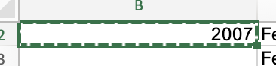
Step 4 - Adding a cleaner year
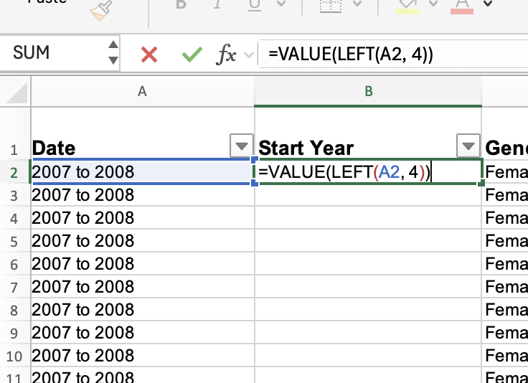
- Right-click the tab No Totals
- Select Move or Copy
- Highlight No Totals
- Check Create a copy
- Rename the duplicate sheet - Start Year
- Right-click column B (gender)
- Select Insert - a new column will be added
- In cell B2 add the following formula =VALUE(LEFT(A2,4))
- Select the cell B2 and then double-click the small green box at the bottom-right of the cell. The formula is ‘pasted down’ the column.

Why?
This step isn’t strictly necessary but it does mean we have a less complicated year value. This will be helpful when creating charts etc. and also will help avoid any filter issues with pivot tables. But we shouldn’t do this lightly. You need to check that we don’t change or remove meaning and context in the data. Something we might forget or lose as we develop our work - "If we change '2007 to 2008' to '2007', are we losing information? How would we explain that to a reader?”

Step 5: Saving a cleaned-up version

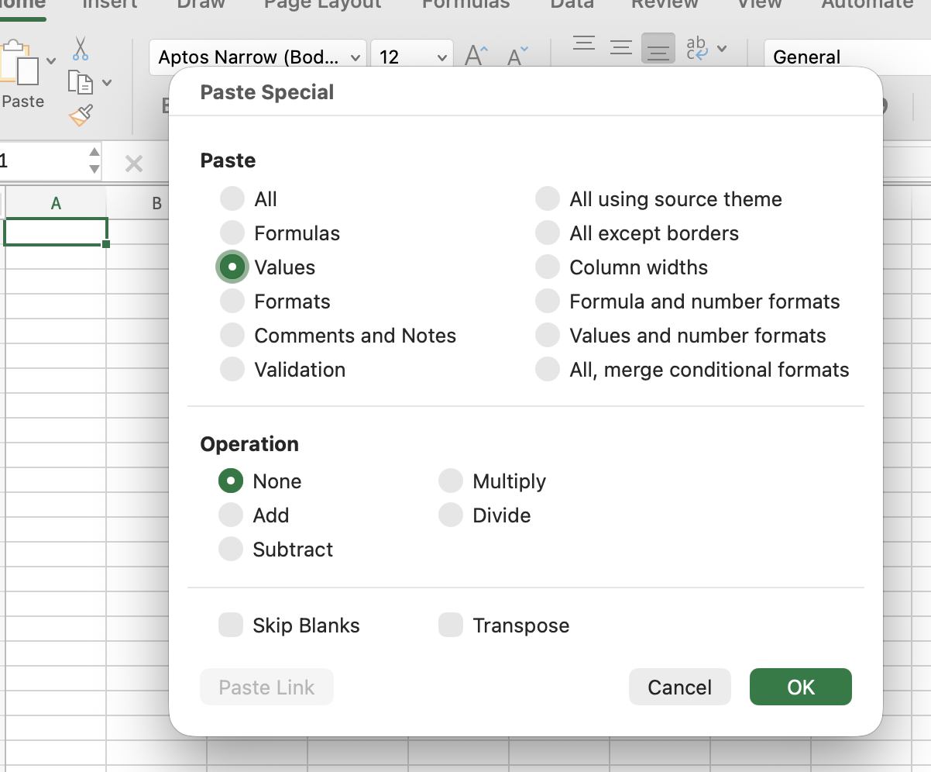
- Working in Start Year…
- Use CTRL+A or Command+A to select all the rows in the sheet.
- Select Edit > Copy
- Select File > New and create a new blank workbook
- Select the first cell in the new workbook
- Select Edit > Paste Special
- Select Values and OK
- Select any Cell and Press CTRL+ SHIFT + L to toggle the column filters on.
- Select File > Save As and save this new file as DRT121C_CLEAN

Why?
It’s never a bad idea to be cautious when working with data. Getting into the habit of saving original files, work-in-progress and cleaned files separately means you always have a reliable copy of the original data to work from (and a way back when the data gets away from you.

